CYBERSECURITY INTERNSHIP
Week 3: Advanced Security & Final Reporting
DevelopersHub Corporation
Intern: Rija Malik
ID: DHC-5363
Date: June 27- 2026
Basic Penetration Testing
In Week 3 basic penetration testing was performed on the OWASP NodeGoat application to evaluate the effectiveness of security measures implemented in Week 2. The following attack simulations were carried out:
XSS Attack Test
XSS payload was entered in the login username field:
<script>alert('XSS');</script>
Result: The script was rendered as plain text no popup was triggered. The autoescape true setting in the Swig template engine successfully blocked the XSS attack.
NoSQL Injection Test
Malicious injection payload was submitted in the login form:
admin' OR '1'='1
Result: Application returned an error message instead of granting unauthorized access. Input validation prevented the injection from reaching the database.
Clickjacking Test
Attempted to embed the application in an iframe on an external page to test clickjacking vulnerability.
Result: X-Frame Options SAMEORIGIN header set by Helmet.js successfully blocked the iframe embedding attempt.
Server Information Disclosure Test
Inspected HTTP response headers to check for server technology leakage.
Result: X-Powered By header was not present in responses. Framework information successfully hidden using app.disable('x-powered-by').
Setting Up Basic Logging with Winston
Winston logging library was installed and configured to monitor all application activities and security events.
npm install winston

logger.js Configuration
const winston = require('winston');
const logger = winston.createLogger({
level: 'info',
format: winston.format.combine(
winston.format.timestamp(),
winston.format.printf(({ timestamp, level, message }) => {
return `${timestamp} [${level.toUpperCase()}]: ${message}`;
})
),
transports: [
new winston.transports.Console(),
new winston.transports.File({ filename: 'security.log' })
]
});
module.exports = logger;
Logging Features Implemented
- All HTTP requests logged with timestamp (GET/POST)
- Database connection events logged
- Server startup events logged
- Invalid input warnings logged
- All logs saved to security.log file
- Console output enabled for real-time monitoring
Screenshot: Winston Logging in VS Code Terminal
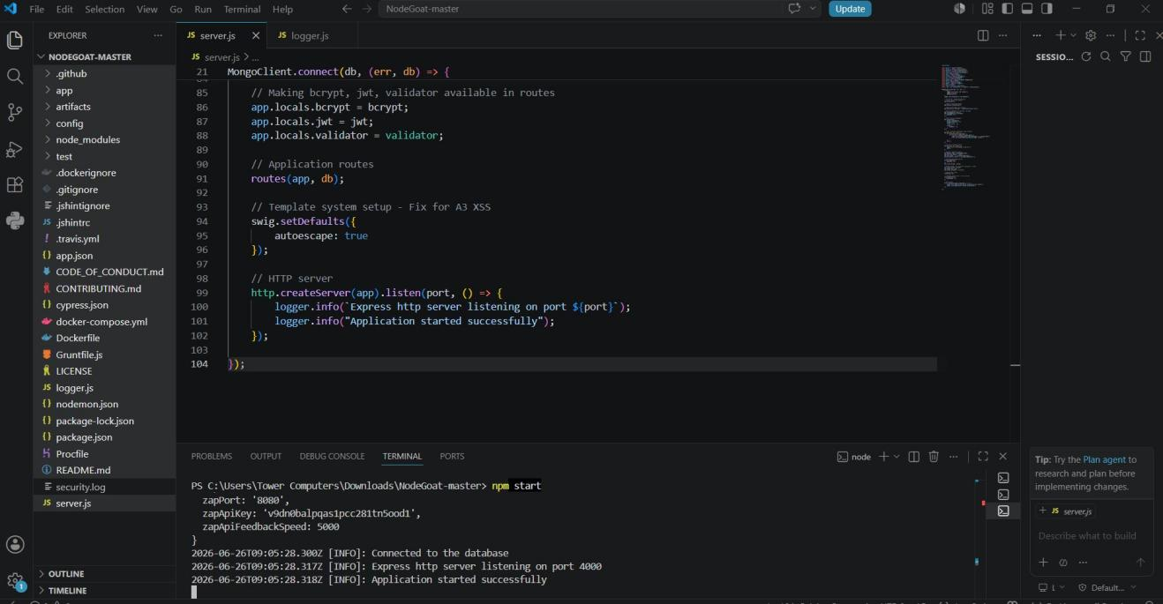
Screenshot 1: Winston logging active server.js with logger.info() calls and terminal showing INFO logs

Screenshot: security.log File
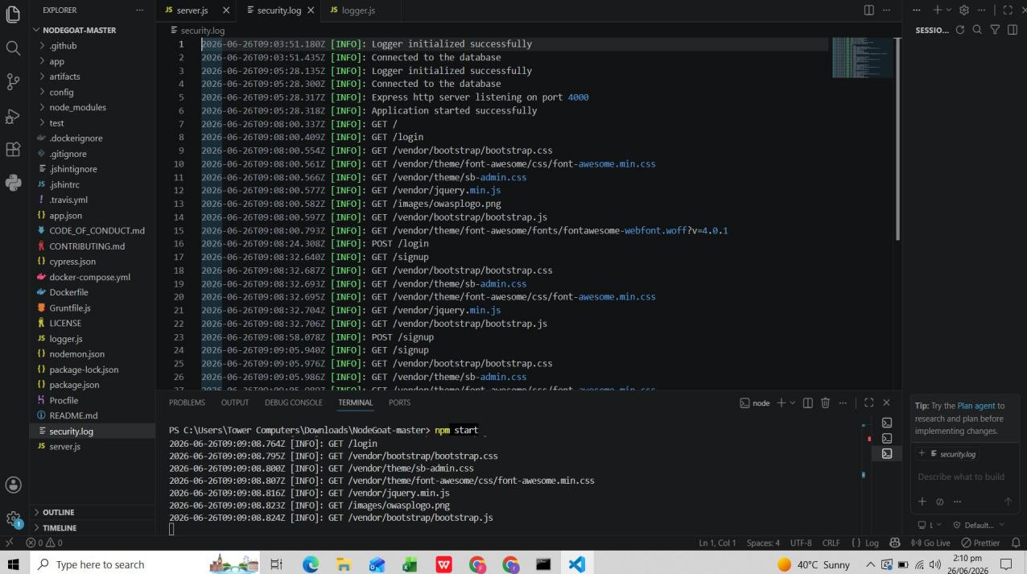
Screenshot 2: security.log file showing all logged events with timestamps GET/POST requests, login attempts, signup events
-------End---------

